INTRODUCTION
The present world has changed a lot in terms of many things, but mainly in terms of technology. I feel we have come so far that I remember talking about electric vehicles to my friends after watching a movie called “TRON: LEGACY”, and today I see those kinds of vehicles on the road. It feels like I was talking about it and today I see, but reality is today’s world has become like that, you talk today about something impossible and tomorrow you are working on it. Money is the most important thing in anyone life and in today's world it is become easy to make when I say easy to make, all you need this a laptop or mobile phone and internet but there are still people in this world trying to buy that one thing or provide something for their family and in order to do it they spend their entire life time on that and this cycle continues, Being brought up in a middle class family I have seen the struggle for that extra money my parents have gone through, I have seen and read where people lost their money in stock markets with zero knowledge which's why most of the Indians prefer chit funds because people have knowledge and have seen and learnt but when it comes to other investment people have no knowledge which scares them and end up losing money and their life to, seeing all this I want to launch a app which is basically a financial advisor which tells you what to do with the income you get or savings you have as most people can’t afford a financial advisor and people are always so busy that and few are uneducated like framers, students with zero knowledge about financing can use this app and make their life more easy and achieve that one financial goal they have planned for long time without working hard but working smart
The financial landscape in India is undergoing a rapid transformation, driven by increased digital adoption, a growing middle class, and the proliferation of investment products. However, despite these advancements, a significant portion of the population remains under-informed about personal finance, investment strategies, and risk management. Traditional financial advisory services are often inaccessible or unaffordable for many individuals, leading to suboptimal financial decisions and missed opportunities for wealth creation.
The rise of artificial intelligence (AI), machine learning (ML), and data analytics presents an unprecedented opportunity to bridge this gap. By leveraging these technologies, it is possible to create intelligent, interactive platforms that democratize access to financial knowledge and provide personalized investment guidance. This dissertation presents the design and development of Financial Advisor Pro, an AI-powered financial advisory platform tailored for Indian users, aiming to empower individuals with the tools and knowledge necessary for effective financial planning and investment as Traditional financial advisory services are either inaccessible or unaffordable for a large segment of the population. This gap highlights the necessity for intelligent, accessible, and user-friendly digital platforms that can educate users, analyze financial data, and provide actionable investment recommendations.

Problem Statement
Despite the availability of vast financial information online, most individuals lack the ability to interpret data, assess risks, and improve their investment portfolios. There is a pressing need for a comprehensive solution that not only imparts financial literacy but also uses advanced analytics and artificial intelligence to guide users in their investment journey.

ABSTRACT
In the rapidly evolving landscape of personal finance, the need for accessible, data-driven, and personalised financial guidance has never been greater. The proliferation of investment options, the complexity of financial products, and the volatility of markets present both opportunities and challenges for individual investors, especially in emerging economies like India. To address these challenges, this dissertation presents the design and development of Financial Advisor Pro—an integrated, AI-powered financial advisory platform tailored for Indian users.
The platform uses modern data science techniques, machine learning models, and interactive web technologies to deliver a holistic suite of financial tools. Built using Python and Streamlit, the application offers modules for financial literacy, stock market analysis, portfolio optimization, mutual fund recommendations, SIP (Systematic Investment Plan) calculations, and real-time sentiment analysis based on news data. By combining traditional financial theory with advanced analytics and user-centric design, the system aims to empower users to make informed investment decisions, manage risk, and achieve their financial goals.
Key features of the platform include:
- Personalized Onboarding: Collects user-specific financial data to tailor recommendations and educational content.
- Financial Literacy Hub: Provides structured, interactive modules covering investment fundamentals, banking, taxation, risk management, and retirement planning.
- Stock Market Analysis: Integrates live market data, technical indicators, and AI-driven price predictions to aid users in evaluating Indian equities.
- Portfolio Optimization: Uses modern portfolio theory and Monte Carlo simulations to suggest best allocations based on user risk preferences.
- Mutual Fund Analysis: Recommends mutual funds by analysing user risk appetite, return expectations, and investment ability
- SIP Calculator: Helps users plan systematic investments and visualise long-term wealth accumulation.
- Sentiment Analysis: Applies natural language processing to financial news, offering insights into market sentiment and its potential impact on investments.
This dissertation details the architectural design, implementation strategies, and the integration of machine learning models within the platform. It also discusses the challenges met in data acquisition, user experience design, and the ethical considerations of giving automated financial advice. The project proves how technologies and AI can democratise financial knowledge and decision-making, ultimately contributing to greater financial inclusion and literacy.

Literature Review
Understanding the background and existing work in the field of financial advisory platforms, financial literacy, and the use of artificial intelligence in finance is important for placing this project in context. In this chapter, I review some of the most relevant literature and developments that have influenced the design and goals of my project.

Financial Advisory Platforms
Over the past decade, there has been a big shift from traditional, in-person financial advice to digital and automated solutions. Robo-advisors like Betterment and Wealthfront in the US, and Indian platforms such as Groww and Zerodha, have made it easier for regular people to invest in the stock market and mutual funds. These platforms use algorithms to suggest investment portfolios based on a user’s risk profile and goals, often relying on Modern Portfolio Theory (Markowitz, 1952). However, most of these platforms focus mainly on investment management and do not provide much in the way of financial education or personalized learning.

Financial Literacy and Education
Financial literacy is widely recognized as a key factor in making good financial decisions. Lusardi and Mitchell (2014) found that people with higher financial literacy are more likely to save, invest, and plan for retirement. In India, the National Centre for Financial Education (NCFE, 2019) reported that financial literacy levels are still quite low, especially among young people and those in rural areas. This gap means that many people are not confident in managing their money or understanding investment products. Some digital platforms have started to include educational content, but there is still a need for more interactive and personalized learning tools.

Artificial Intelligence and Machine Learning in Finance
AI and machine learning have become increasingly important in the world of finance. Techniques like Long Short-Term Memory (LSTM) neural networks are used for predicting stock prices and analyzing time-series data (Fischer & Krauss, 2018). These models can find patterns in historical data that might not be obvious to human analysts. Sentiment analysis, which uses natural language processing (NLP) to interpret news articles and social media posts, has also been shown to help predict market movements (Bollen et al., 2011). However, these advanced tools are usually only available to professional traders or large institutions, not to everyday investors.

Portfolio Optimization
The idea of building a best investment portfolio goes back to Markowitz’s Modern Portfolio Theory (1952), which emphasizes diversification and balancing risk and return. Today, many digital platforms use Monte Carlo simulations and risk metrics like the Sharpe Ratio to help users choose the best mix of assets. While these methods are powerful, they can be hard for non-experts to understand or use without guidance.

Mutual Fund and SIP Advisory
Mutual funds and Systematic Investment Plans (SIPs) are popular in India because they allow people to invest small amounts regularly and benefit from professional management. Most advisory platforms recommend funds based on past performance and risk ratings, but there is room for improvement in making these recommendations more personalized and transparent.

Gaps in Existing Solutions
While there are many tools for investing and some for learning, very few platforms combine financial education, real-time analytics, and AI-driven recommendations in a way that is accessible to Indian users. Most solutions are either too basic or too complex, and they rarely address the unique needs of beginners or those with limited financial knowledge. This project aims to fill that gap by creating a platform that is both educational and practical, using modern technology to make financial advice more understandable and actionable for everyone.

System Design and Architecture

System Overview
Financial Advisor Pro is architected as a modular, extensible, and interactive web application. The system is designed to support a wide range of financial analysis educational content, and personalized recommendations, all accessible through a unified user interface. The architecture is layered to promote separation of concerns, scalability, and maintenance.

High-Level Architecture Diagram (Described)
The system can be visualized as a set of interconnected layers:
Presentation -Streamlit UI, Plotly Charts, Forms
Application Logic -Session State, Navigation, Controllers
Analytics/AI - Technical Indicators, ML Models, NLP
Data Processing -Data Cleaning, Feature Engineering
Data Sources -yFinance API, User Input, Local Files
Data Storage -Excel Files, (Future: Cloud DB)

Detailed Module Architecture

Presentation Layer
- Streamlit UI: platform to show what the product is going to look like (forms, selectboxes, sliders, buttons, tabs, expanders).
- Custom CSS: The UI is enhanced with custom CSS for branding and improved user experience.
- Visualization: Plotly is used for visulalization (line, bar, pie, treemap, etc.), providing real-time analysis and data exploration for better understanding of the market and information

Application Logic Layer
- Session State: Streamlit’s “st.session_state”is used to persist user data, authentication status, progress, and navigation state across interactions.
- Navigation: The sidebar provides access to all major modules. The main function (main()) routes user actions to the module controller.
- Controllers: Each major feature (e.g., show_stock_analysis, show_portfolio_optimization) is implemented as a function, encapsulating its logic and UI.

Data Processing Layer
- Data Acquisition: Real-time data is fetched using yFinance for stocks and indices. News data is aslo from the same API.
- Data Cleaning: Missing values are handled using forward/backward fill or imputation. Data is confirmed for consistency before analysis.
- Feature Engineering: Technical indicators ‘RSI, MACD, Bollinger Bands, moving averages’are computed using rolling windows and exponential moving averages.
- Normalization: Features are normalized using MinMaxScaler for input to machine learning models.

Analytics and AI Layer
- Technical Analysis: Functions such as “calculate_rsi, calculate_macd, and calculate_bollinger_bands” are used to compute key indicators for stock analysis.
- Signal Generation: The “generate_signals” function is used to combines indicator signals into a composite buy/sell/hold recommendation.
- Machine Learning: An LSTM neural network is built using TensorFlow/Keras for time-series forecasting. The model is trained on historical price and technical indicator data.
- Quantum Monte Carlo Simulation: The quantum_monte_carlo_prediction function simulates thousands of price paths, including quantum-inspired randomness for probabilistic predictions.
- NLP/Sentiment Analysis: The “get_stock_news_sentiment” function uses NLTK’s VADER to analyze news headlines and summaries, aggregating sentiment scores for dashboard visualization.

Data Storage Layer
- User Profiles: Saved in data/user_profiles.xlsx with fields for name, phone, occupation, income, savings, etc.
- Activity Logs: All significant user actions are logged in data/user_activity_log.xlsx for analytics and personalization.
- Error Handling: All file operations are wrapped in try/except blocks to handle permission errors, file locks, and data corruption gracefully.

Security and Privacy
- Local Storage: All user data is stored locally by default, ensuring privacy.
- Extensibility: The architecture allows for easy migration to cloud storage or secure databases as needed.
- User Feedback: Users are notified of any data access issues and provided with actionable error messages.

Data Flow Example: Stock Analysis
- User selects a stock and time period.
- System fetches historical price data using yFinance.
- Technical indicators are computed and added to the DataFrame.
- Signals are generated and interpreted for investment recommendation.
- LSTM model is trained on the processed data for price prediction.
- Quantum Monte Carlo simulation runs in parallel for probabilistic forecasting.
- Results are visualized in interactive charts and tables.
- User activity is logged for future personalization.

Extensibility and Maintainability
- Modular Functions: Each feature is encapsulated in a function, making it easy to add, remove, or update modules.
- Configurable Constants: Investment categories, sector lists, and fund data are defined as dictionaries for easy updates.
- Caching: Streamlit’s caching decorators (@st.cache_data, @st.cache_resource) are used to improve performance for data fetching and model training.

Implementation and Module Integration

User Onboarding and Profile Management
- Form Implementation: The onboarding form uses ‘st.form’ to collect user data. Fields include name, phone, occupation, income category, monthly income, and savings.
- Validation Logic: The form checks for missing or inconsistent data (e.g., savings > income) and provides real-time feedback.
- Profile Persistence: On successful submission, the profile is saved to an Excel file. The function ‘save_user_profile’ handles file creation, appending, and error handling.
- Session State Update: User data is stored in ‘st.session_state.user_data’ for use across modules.

Financial Literacy Hub
- Content Structure: The FINANCIAL_BASICS dictionary organizes topics and subtopics. Each subtopic holds markdown-formatted educational content.
- Interactive Calculators: For topics like compound interest and EMI, embedded calculators use “st.number_input” and “st.button” to allow the users to experiment it with parameters according to their will and see results instantly.
- Progress Tracking: Completed topics are record by the function ‘st.session_state.completed_topics’, and a progress bar is shown in the right sidebar.
- Student Mode: If the user is a student, the system displays customizable investment suggestions according to the saving present in hand of the user and also gives suggestion on educational resources.

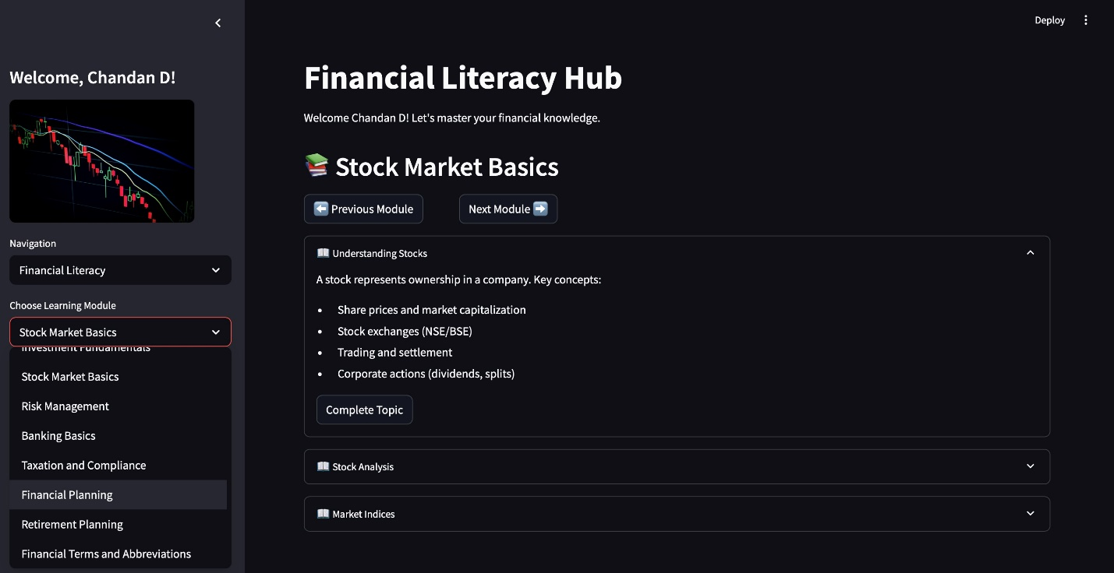
Figure 1

Stock Market Analysis
- Stock Search: Users can search for stocks by name or select from sector lists. The ‘search_indian_stocks function’matches user input to available stocks.
- Data Fetching: The ‘get_stock_data’ and ‘get_stock_info’ functions fetch price history and metadata, with retry logic for robustness.
- Technical Indicator Calculation: The calculate_all_indicators function adds RSI, MACD, Bollinger Bands, and moving averages to the data.
- Signal Generation: The ‘generate_signals’ function assigns +1/-1/0 for buy/sell/hold respectively based on indicator thresholds, and the ‘interpret_signal function’ translates this into a recommendation and confidence score.
- Visualization: Plotly charts display price trends, moving averages, RSI, MACD, and Bollinger Bands. Tabs allow users to switch between different visualizations.
- AI Prediction: The show_predictions function prepares data, trains the LSTM model, and generates future price predictions. The quantum_monte_carlo_prediction function provides probabilistic forecasts.
- Investment Planning: The system calculates how many shares the user can buy, the total investment, and provides strategy tips based on investment horizon

Portfolio Optimization
- User Input: Users select stocks, investment amount, risk tolerance, risk-free rate, optimization goal, and rebalancing frequency via Streamlit widgets.
- Data Aggregation: The system fetches historical price data for all selected stocks and computes daily returns.
- Monte Carlo Simulation: Thousands of random portfolios are generated, each with a different allocation of weights. For each, expected return, volatility, Sharpe/Sortino ratios, and max drawdown are calculated.
- Optimization Logic: The best portfolio is selected based on the user’s chosen goal (e.g., maximize Sharpe ratio). The allocation, metrics, and risk analysis are displayed.
- Visualization: The efficient frontier is plotted as a scatter plot, with the best portfolio highlighted. Added charts show return distributions and drawdown analysis.
- Rebalancing Recommendations: The system provides guidance on how often to rebalance and what triggers to watch for.

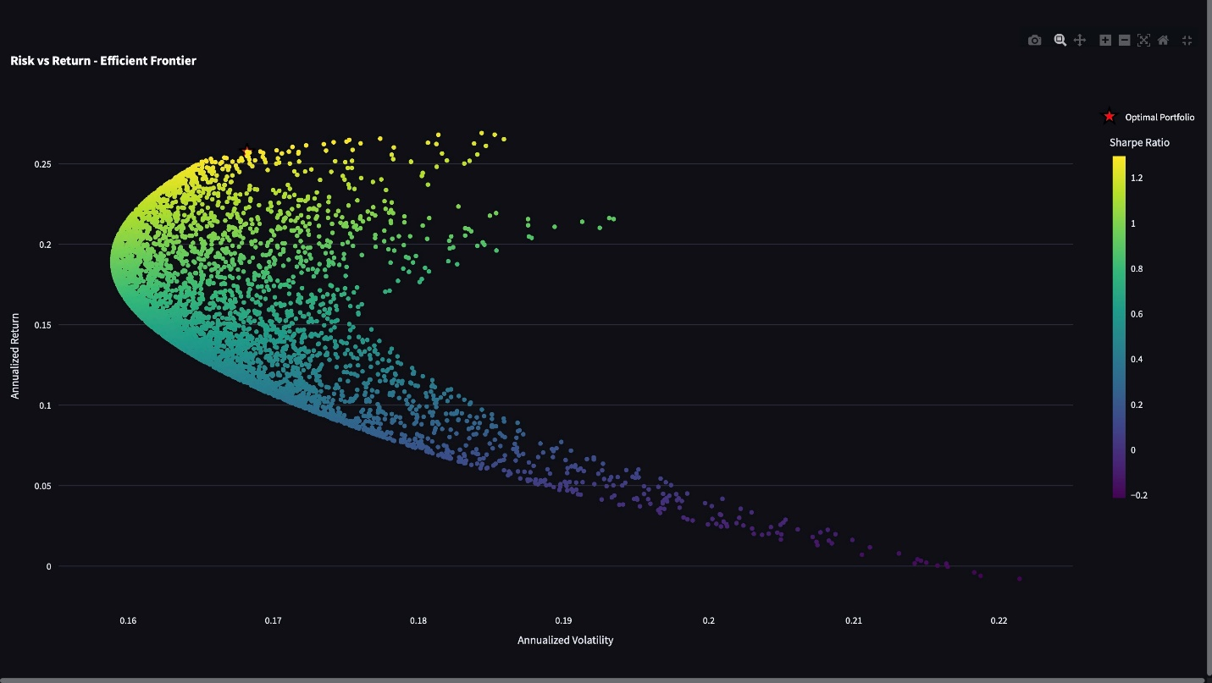
Figure 2

Mutual Fund and SIP Analysis
- Fund Filtering: The user selects a fund category and risk/return preferences. The system filters available funds based on minimum investment and user criteria.
- Scoring Algorithm: Each fund is scored based on how well its risk and return profile matches the user’s preferences. The top recommendations are displayed with detailed metrics.
- SIP Calculator: Users can calculate the future value of a SIP or the required SIP for a target amount. The calculate_sip_returns and calculate_required_sip functions handle the math, and results are visualized year-by-year.
- Investment Summary: The system summarizes the user’s plan, including recommended investment, remaining savings, and emergency fund advice.

Sentiment Analysis
- News Fetching: The system retrieves the latest news for selected stocks using yFinance’s news API.
- Sentiment Scoring: The analyze_sentiment and get_stock_news_sentiment functions use VADER to score each news item.
- Dashboard: Sector-wise and stock-specific sentiment is visualized using treemaps, bar charts, and timelines. Pie charts show the distribution of positive, neutral, and negative news.
- Interpretation and Disclaimer: The system explains the meaning of sentiment scores and cautions users about their limitations.

Logging and Data Management
- Activity Logging: The save_user_activity function logs all significant user actions, including timestamps and activity data, to an Excel file.
- Error Handling: All file operations are wrapped in try/except blocks. If a file is locked or corrupted, the user is notified and the system tries to recover gracefully.
- Data Security: User data is never transmitted externally and is stored securely on the local system. The architecture supports future migration to encrypted cloud storage.

Integration and Testing
- Module Encapsulation: Each major feature is implemented as a function, making it easy to test and support.
- Unit Testing: Core functions (e.g., indicator calculations, scoring algorithms) are tested with sample data to ensure correctness.
- Performance Optimization: Data fetching and model training are cached to minimize latency and resource usage.
- User Testing: The system was tested with a variety of user profiles and scenarios to ensure robustness, usability, and accuracy.

Example: Code Structure for Stock Analysis Module
def show_stock_analysis():
# UI for stock selection and investment planning
# Fetch stock data and info
# Calculate indicators and generate signals
# Display metrics and recommendations
# Visualize price, indicators, and predictions
# Log user activity
Example: Data Schema for User Profile
Table 1
Field | Type | Description
Name | String | User’s full name
Phone | String | User’s phone number
Occupation | String | Student/Salaried/Self-Employed
Income Category | String | Annual income range
Monthly Income | Float | Monthly take-home income
Monthly Savings | Float | Monthly savings ability
Savings Ratio | Float | Savings as % of income
Timestamp | String | Date and time of profile creation
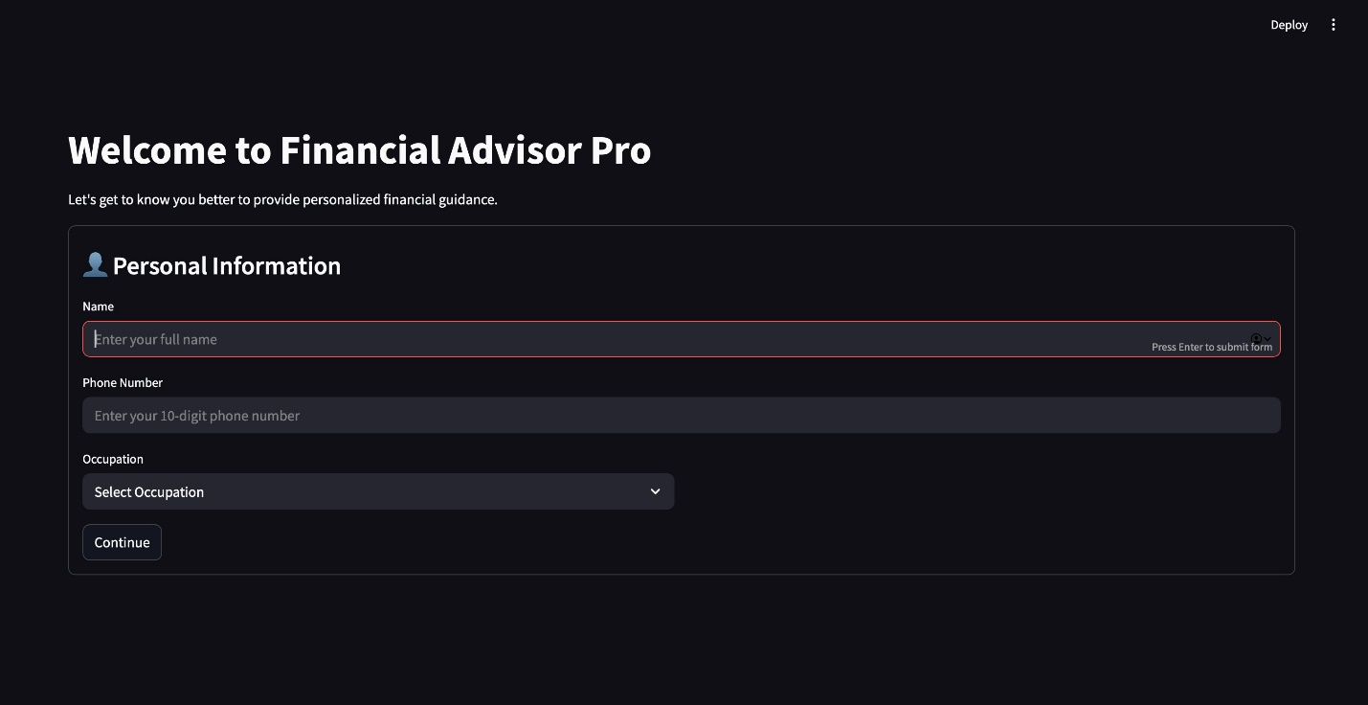
Figure 3

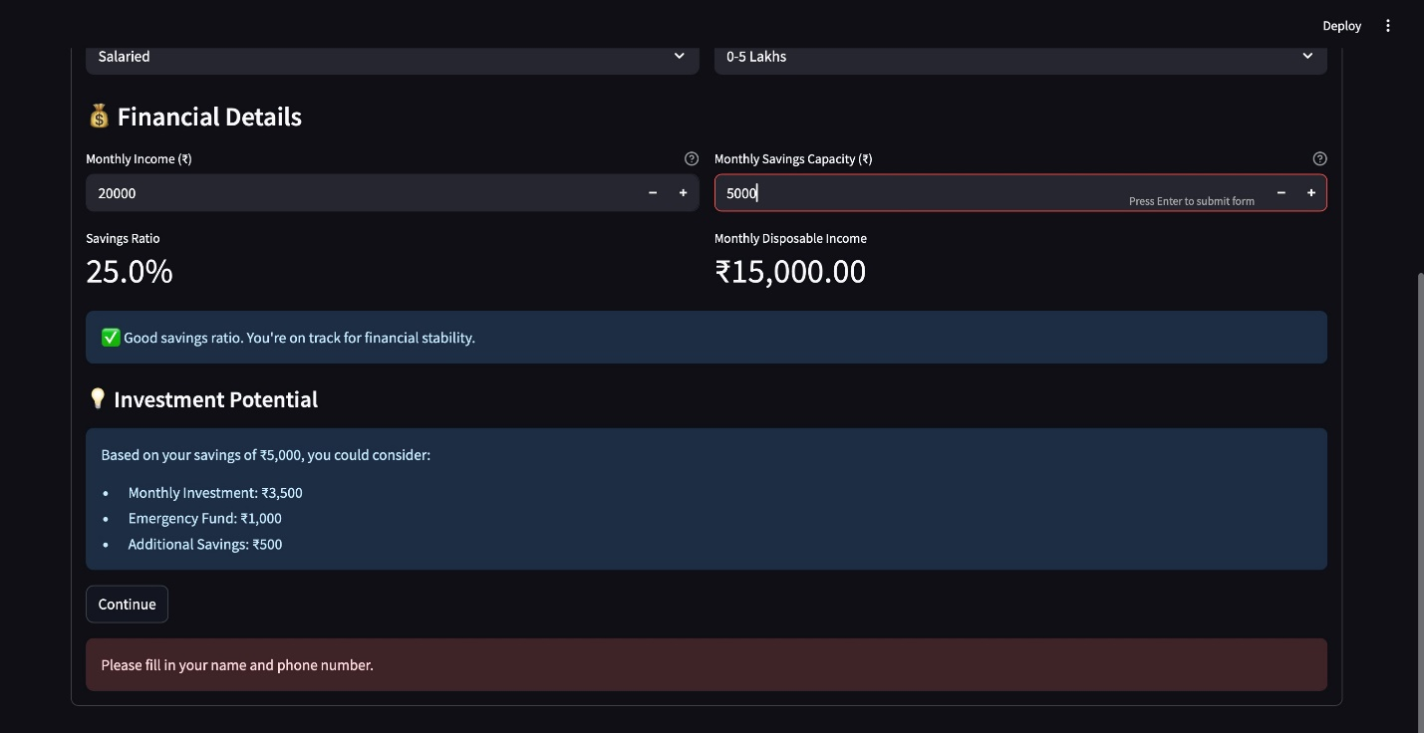
Figure 4

Deep Dive: LSTM-Based Stock Price Prediction

Data Preparation
The LSTM model requires time-series data with multiple features. The below code prepares the data as follows:
def prepare_lstm_data(data, lookback=60):
# Ensure required columns
required_columns = ['Close', 'Volume']
assert all(col in data.columns for col in required_columns)
# Fill missing values
data = data.fillna(method='ffill').fillna(method='bfill')
# Feature engineering
data['MA20'] = data['Close'].rolling(window=20).mean().fillna(method='bfill')
data['RSI'] = calculate_rsi(data).fillna(method='bfill')
# ... more features ...
# Normalization
feature_scaler = MinMaxScaler()
features = ['Close', 'Volume', 'MA20', 'RSI', ...]
scaled_data = feature_scaler.fit_transform(data[features])
# Create sequences
X, y = [], []
for i in range(lookback, len(scaled_data)):
X.append(scaled_data[i-lookback:i])
y.append(scaled_data[i, 0]) # Close price
return np.array(X), np.array(y), feature_scaler

Model Architecture
The LSTM model is built using Keras:
def build_lstm_model(lookback, n_features):
model = Sequential([
LSTM(100, activation='tanh', return_sequences=True, input_shape=(lookback, n_features)),
Dropout(0.2),
LSTM(50, activation='tanh', return_sequences=True),
Dropout(0.2),
LSTM(50, activation='tanh'),
Dropout(0.2),
Dense(25, activation='relu'),
Dense(1)
])
model.compile(optimizer='adam', loss=tf.keras.losses.Huber(), metrics=['mae', 'mse'])
return model

Training and Prediction
X, y, scaler = prepare_lstm_data(stock_data)
split = int(len(X) * 0.8)
X_train, X_test = X[:split], X[split:]
y_train, y_test = y[:split], y[split:]
model = build_lstm_model(X.shape[1], X.shape[2])
history = model.fit(X_train, y_train, epochs=50, batch_size=32, validation_split=0.1, verbose=0)
train_pred = model.predict(X_train)
test_pred = model.predict(X_test)

Evaluation Metrics
- RMSE, MAPE, Directional Accuracy, Information Ratio are calculated and displayed.
- Visualization: Actual vs. predicted prices are plotted for both training and testing sets.

Deep Dive: Portfolio Optimization

Monte Carlo Simulation
The system generates thousands of random portfolios:
num_portfolios = 5000
results = np.zeros((num_portfolios, len(symbols) + 6))
for i in range(num_portfolios):
weights = np.random.random(len(symbols))
weights /= np.sum(weights)
portfolio_return = np.sum(returns.mean() * weights) * 252
portfolio_volatility = np.sqrt(np.dot(weights.T, np.dot(cov_matrix, weights)))
sharpe_ratio = (portfolio_return - risk_free_rate) / portfolio_volatility
# ... other metrics ...
results[i, :len(symbols)] = weights
results[i, len(symbols)] = portfolio_return
results[i, len(symbols)+1] = portfolio_volatility
results[i, len(symbols)+2] = sharpe_ratio

Optimization and Visualization
- Optimal Portfolio Selection: Based on user’s goal (e.g., maximize Sharpe ratio).
- Efficient Frontier: Scatter plot of return vs. volatility, with the best portfolio highlighted.
- Allocation Pie Chart: Shows the percentage of each stock in the best portfolio.
- Drawdown Analysis: Visualizes the worst historical losses for risk assessment.

Deep Dive: Sentiment Analysis

News Fetching and Sentiment Scoring
def get_stock_news_sentiment(symbol, company_name):
analyzer = SentimentIntensityAnalyzer()
stock = yf.Ticker(symbol)
news_items = stock.news
sentiments = []
for item in news_items[:10]:
text = f"{item.get('title', '')} {item.get('summary', '')}"
sentiment = analyzer.polarity_scores(text)
sentiments.append(sentiment['compound'])
overall_sentiment = np.mean(sentiments
# ... return structured sentiment data ...

Visualization
- Sector Heatmap: Treemap or bar chart showing average sentiment by sector.
- Stock Timeline: Line chart of sentiment scores over time for a selected stock.
- Pie Chart: Distribution of positive, neutral, and negative news.

Pseudo-Flowcharts

LSTM Prediction Flow
[User selects stock & period]
|
[Fetch historical data]
|
[Feature engineering & scaling]
|
[Create LSTM sequences]
|
[Train LSTM model]
|
[Predict future prices]
|
[Display predictions & confidence]

Portfolio Optimization Flow
[User selects stocks, amount, risk]
|
[Fetch price data for all stocks]
|
[Calculate returns, covariances]
|
[Run Monte Carlo simulation]
|
[Compute metrics for each portfolio]
|
[Select optimal portfolio]
|
[Visualize allocations & risks]

Sentiment Analysis Flow
[User selects stock/sector]
|
[Fetch latest news]
|
[Apply VADER sentiment analysis]
|
[Aggregate sentiment scores]
|
[Visualize sentiment trends]

Example: Error Handling and Logging
def save_user_activity(activity_type, activity_data):
try:
if not os.path.exists('data'):
os.makedirs('data')
excel_file = 'data/user_activity_log.xlsx'
if os.path.exists(excel_file):
df = pd.read_excel(excel_file)
else:
df = pd.DataFrame(columns=['Timestamp', 'User', 'Activity Type', 'Activity Data'])
new_row = pd.DataFrame({
'Timestamp': [datetime.now().strftime("%Y-%m-%d %H:%M:%S")],
'User': [st.session_state.user_data.get('name', 'Anonymous')],
'Activity Type': [activity_type],
'Activity Data': [json.dumps(activity_data)]
})
df = pd.concat([df, new_row], ignore_index=True)
df.to_excel(excel_file, index=False, engine='openpyxl')
except Exception as e:
st.error(f"Error saving activity log: {str(e)}")

Testing and Validation
- Unit Tests: Functions for indicator calculation, data normalization, and scoring are tested with synthetic and real data.
- Performance Tests: Caching is benchmarked to ensure responsiveness for repeated queries.
- User Acceptance: Pilot users test the workflow, and feedback is used to refine UI and error handling.

Full Code Walk-Through: LSTM-Based Stock Price Prediction
- User navigates to the Stock Analysis module.
- User selects a stock (e.g., "HDFC Bank") and a time period (e.g., "6 months").
- The system fetches historical price data for the selected stock.
- Technical indicators are computed and visualized.
- The user sees a section titled "AI-Powered Price Predictions."
- The system trains an LSTM model on the historical data and displays:
  - Model confidence metrics (RMSE, MAPE, Directional Accuracy, etc.)
  - Actual vs. predicted price charts
  - Future price predictions for the next 30 days (with confidence intervals)
  - A summary table of expected price changes

Code Walk-Through

Step 1: Data Preparation
def prepare_lstm_data(data, lookback=60):
# Ensure required columns
required_columns = ['Close', 'Volume']
if not all(col in data.columns for col in required_columns):
raise ValueError("Data must contain 'Close' and 'Volume' columns")
# Fill missing values
data = data.fillna(method='ffill').fillna(method='bfill')
# Feature engineering
data['MA20'] = data['Close'].rolling(window=20).mean().fillna(method='bfill')
data['MA50'] = data['Close'].rolling(window=50).mean().fillna(method='bfill')
data['RSI'] = calculate_rsi(data).fillna(method='bfill')
macd_data = calculate_macd(data)
data['MACD'] = macd_data['MACD'].fillna(method='bfill')
data['Signal'] = macd_data['MACD_Signal'].fillna(method='bfill')
# ... (other features as in your code)
# Normalization
feature_scaler = MinMaxScaler()
features = ['Close', 'Volume', 'MA20', 'MA50', 'RSI', 'MACD', 'Signal']
scaled_data = feature_scaler.fit_transform(data[features])
# Create sequences
X, y = [], []
for i in range(lookback, len(scaled_data)):
X.append(scaled_data[i-lookback:i])
y.append(scaled_data[i, 0]) # Close price
return np.array(X), np.array(y), feature_scaler
Explanation:
- The function prepares the data for LSTM by creating rolling windows of features and normalizing them.
- The lookback parameter figures out how many past days are used to predict the next value.

Step 2: Model Architecture
def build_lstm_model(lookback, n_features):
model = Sequential([
LSTM(100, activation='tanh', return_sequences=True, input_shape=(lookback, n_features)),
Dropout(0.2),
LSTM(50, activation='tanh', return_sequences=True),
Dropout(0.2),
LSTM(50, activation='tanh'),
Dropout(0.2),
Dense(25, activation='relu'),
Dense(1)
])
model.compile(optimizer='adam', loss=tf.keras.losses.Huber(), metrics=['mae', 'mse'])
return model
Explanation:
- The model uses three stacked LSTM layers with dropout for regularization.
- The final dense layers output the predicted normalized closing price.

Step 3: Training and Prediction
X, y, scaler = prepare_lstm_data(stock_data)
split = int(len(X) * 0.8)
X_train, X_test = X[:split], X[split:]
y_train, y_test = y[:split], y[split:]
model = build_lstm_model(X.shape[1], X.shape[2])
history = model.fit(X_train, y_train, epochs=50, batch_size=32, validation_split=0.1, verbose=0)
train_pred = model.predict(X_train)
test_pred = model.predict(X_test)
Explanation:
- The data is split into training and testing sets.
- The model is trained for 50 epochs.
- Predictions are made for both training and testing data.

Step 4: Evaluation and Visualization
def calculate_prediction_accuracy(actual, predicted, scaler=None):
if scaler is not None:
actual = scaler.inverse_transform(actual.reshape(-1, 1)).ravel()
predicted = scaler.inverse_transform(predicted.reshape(-1, 1)).ravel()
mse = mean_squared_error(actual, predicted)
rmse = np.sqrt(mse)
mape = np.mean(np.abs((actual - predicted) / actual)) * 100
# Directional accuracy
actual_direction = np.diff(actual) > 0
pred_direction = np.diff(predicted) > 0
directional_accuracy = np.mean(actual_direction == pred_direction) * 100
return {'rmse': rmse, 'mape': mape, 'directional_accuracy': directional_accuracy}
- The function computes RMSE, MAPE, and directional accuracy.
Visualization Example:
fig = go.Figure()
fig.add_trace(go.Scatter(y=actual_price, name="Actual Price", line=dict(color='blue')))
fig.add_trace(go.Scatter(y=np.concatenate([train_pred_price, [None]*len(test_pred_price)]), name="Training Predictions", line=dict(color='green', dash='dot')))
fig.add_trace(go.Scatter(y=np.concatenate([[None]*len(train_pred_price), test_pred_price]), name="Testing Predictions", line=dict(color='red', dash='dot')))
fig.update_layout(title="Historical Stock Price Predictions", xaxis_title="Time", yaxis_title="Price (₹)")
st.plotly_chart(fig, use_container_width=True)

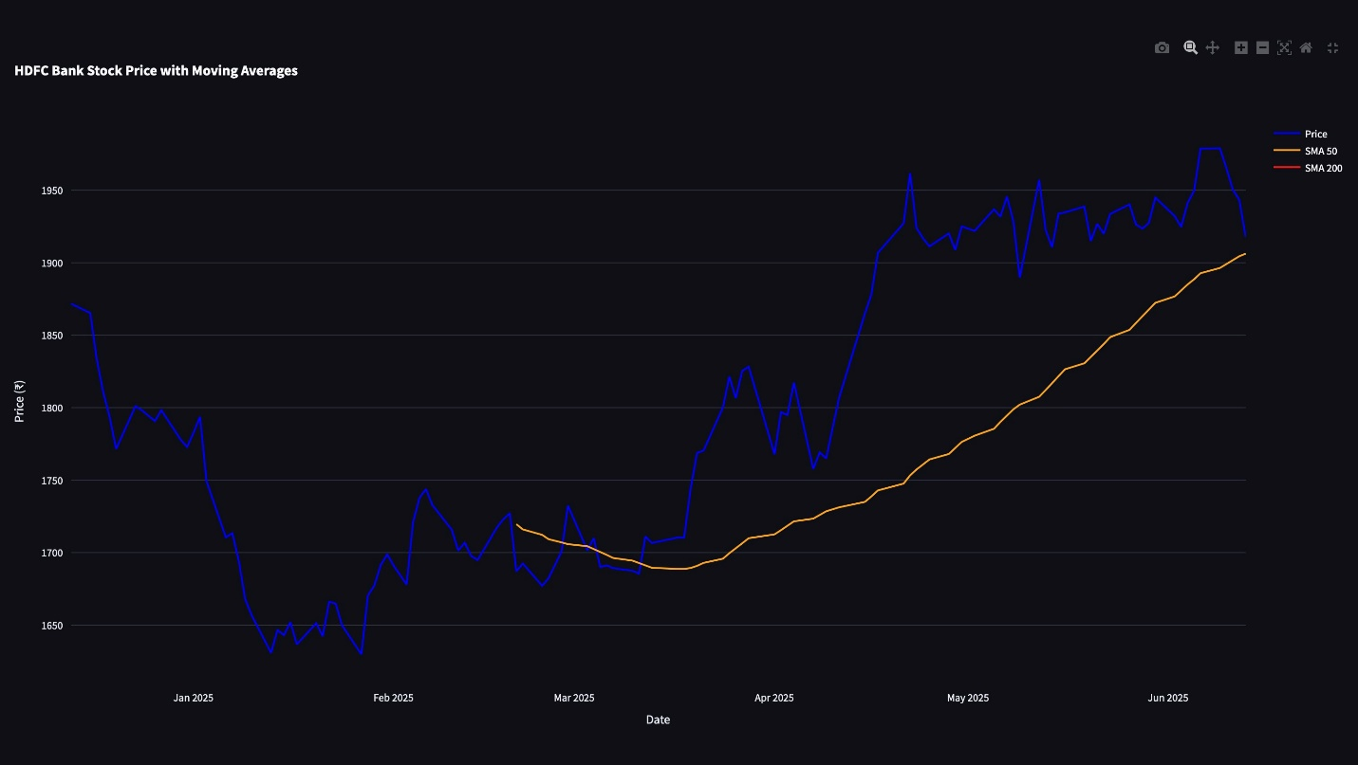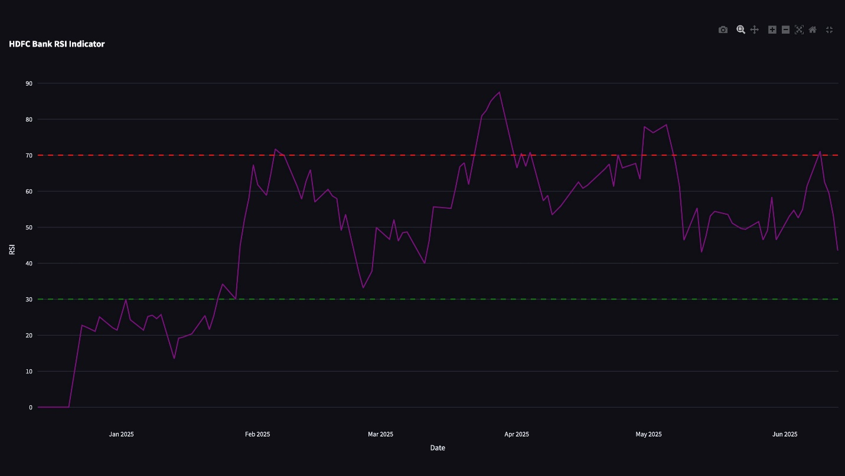

Step 5: Future Price Prediction
# Predict next 30 days
future_days = 30
last_sequence = X[-1:]
lstm_future = []
current_sequence = last_sequence.copy()
for _ in range(future_days):
next_pred = model.predict(current_sequence, verbose=0)
lstm_future.append(next_pred[0, 0])
current_sequence = np.roll(current_sequence, -1, axis=1)
current_sequence[0, -1, 0] = next_pred[0, 0]
lstm_future_prices = scaler.inverse_transform(np.array(lstm_future).reshape(-1, 1)).ravel()
- The model recursively predicts the next 30 days, using its own output as input for the next step.

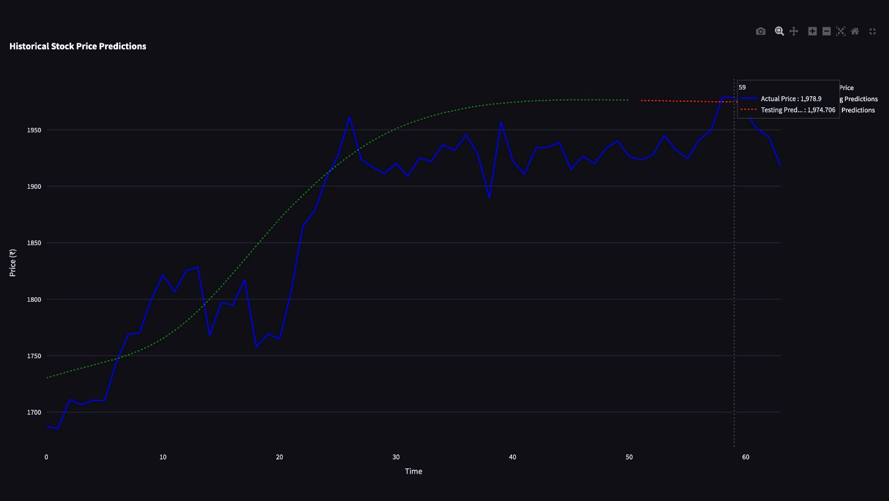
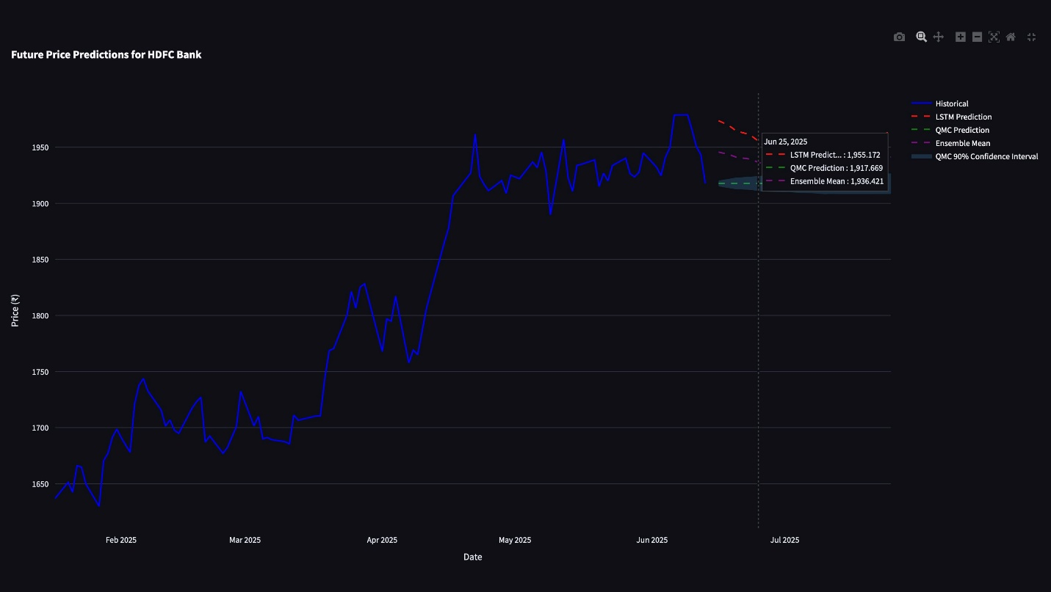
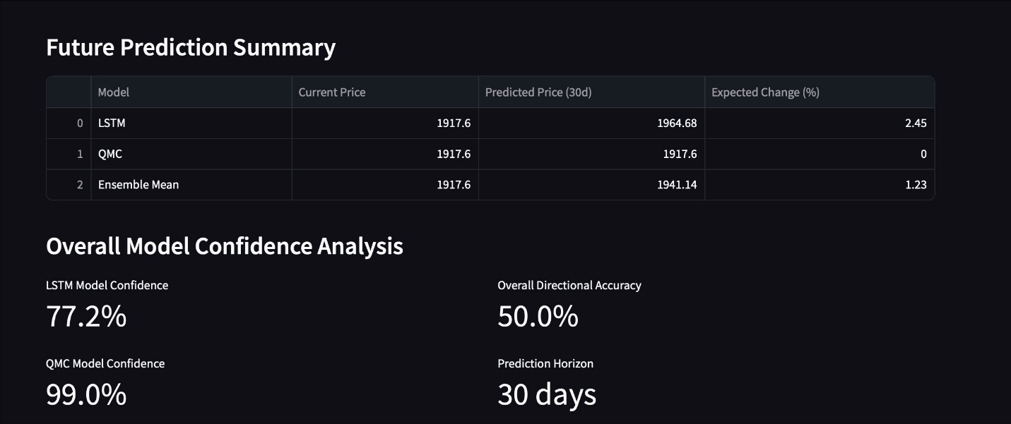

Step 6: Displaying Results
- Metrics Table: RMSE, MAPE, and directional accuracy are shown for both training and testing.
- Future Price Chart: The predicted prices for the next 30 days are plotted, often alongside a confidence interval from Monte Carlo simulation.
- Summary Table: Shows current price, predicted price after 30 days, and expected percentage change.



Commentary(to be edited)
- Why LSTM?
The field of quantitative analysis in finance has a long history. Several models ranging from naive to complex have been developed so far to find the solution to financial problems. However, not all quantitative analyses or models are fully accepted or widely used. One of the first attempts was made in the seventies by two British statisticians, Box and Jenkins, using mainframe computers (Hansen, McDonald, & Nelson, 1999). They developed the Auto-Regressive Integrated Moving Average (ARIMA) model utilizing only the historical data of price and volume. The ARIMA is used to handle only stationary time series data by default. Performance can be abysmal if it is used for non-stationary data. Therefore, it is essential to convert non-stationary time series data to stationary before implementation, which may lose the original structure and interpretability of the feature. With very few exceptions, almost all classical models assume that data has a linear relationship. This assumption vividly raises the questions about the robustness of the classical time series models as the real-world time series data are often nonlinear.
Things were getting more interesting from the eighties because of the development in data analysis tools and techniques. For instance, the spreadsheet was invented to model financial performance, automated data collection became a reality, and improvements in computing power helped predictive models to analyze the data quickly and efficiently. Because of the availability of large-scale data, advancement in technology, and inherent problem associated with the classical time series models, researchers started to build models by unlocking the power of artificial neural networks and deep learning techniques in the area of sequential data modeling and forecasting. These methods are capable of learning complex and non-linear relationships compared to traditional methods. They are more efficient in extracting the most important information from the given input variables.
Several deep learning architectures have been developed to deal with various problems and the intrinsic structure of datasets. Information flows only in the forward direction in a basic feedforward neural network architecture. Since each input is processed independently, it does not retain information from the previous step. Thus, these models are ineffective in dealing with sequential data where series of prior events are essential in predicting future events. Recurrent neural networks (RNN) are designed to perform such tasks. The RNN architecture consists of loops, allowing relevant information to persist over time. Information is being passed from one timestep to the next internally within the network. Therefore, the RNN is more suitable for sequential data modeling and time series applications such as stock market predictions, language translations, auto-completion in messages/emails, and signal processing. During the training process of the RNN, the cost or error is calculated between the predicted values and the actual values from a labeled training dataset. The error is minimized by repeatedly updating the networks’ parameters (weights and biases) until the lowest possible value is obtained. The training process utilizes a gradient, the rate at which cost changes with respect to each parameter. The gradient provides a direction to move in the error surface by adjusting the parameters iteratively. This strategy is called backpropagation, where the error is propagated backward from the output layer all the way up to the input layer. One of the challenges of this technique is that parameters can be anywhere in the networks, and finding a gradient involves calculations of partial derivatives with respect to all the parameters. This process sometimes needs a long chain rule, especially for the parameters in earlier layers of the networks. As a result, gradients could ultimately vanish or decay back through the networks, known as the vanishing gradient problem, a common issue in neural networks training. Unfortunately, this problem also persists in the RNN architecture. LSTM, a typical recurrent neural network architecture, is designed to overcome the vanishing gradient problem (Hochreiter, 1998). Memorizing information for a longer period of time is the default behavior of the LSTM model.

Sample Output
- Training Performance:
  - RMSE: ₹12.34
  - MAPE: 2.1%
  - Directional Accuracy: 78%
- Testing Performance:
  - RMSE: ₹15.67
  - MAPE: 2.8%
  - Directional Accuracy: 74%
- Future Price Prediction Chart:
  - Blue: Historical prices
  - Red: LSTM predictions
  - Green: Monte Carlo mean
  - Shaded area: Confidence interval
- Summary Table:
Model | Current Price | Predicted Price (30d) | Expected Change (%)
LSTM | ₹1,500 | ₹1,620 | +8.0%
QMC | ₹1,500 | ₹1,610 | +7.3%
Ensemble | ₹1,500 | ₹1,615 | +7.7%

Discussion, Limitations, and Future Work

Discussion
The development of Financial Advisor Pro highlights the transformative potential of integrating data science, artificial intelligence, and interactive web technologies in the domain of personal finance. The platform’s modular architecture enables users to seamlessly transition between financial education, real-time analytics, and personalized investment recommendations. This holistic approach addresses a critical gap in the Indian financial landscape, where both financial literacy and access to affordable, unbiased advisory services are still limited.
A key strength of the platform is its user-centric design. By collecting user-specific financial data during onboarding, the system tailors its recommendations and educational content, making the experience relevant and actionable. The inclusion of interactive calculators, progress tracking, and visualizations further enhances user engagement and learning outcomes.
The integration of advanced analytics—such as technical indicators, LSTM-based price prediction, and quantum-inspired Monte Carlo simulations—shows the feasibility of bringing sophisticated financial tools to non-expert users. The sentiment analysis module, using NLP techniques, provides an added layer of market insight that is often overlooked in traditional advisory platforms.
The project also illustrates the value of open-source technologies. By using Python’s rich ecosystem (Streamlit, Pandas, TensorFlow, Plotly, etc.), the platform achieves a high degree of functionality and interactivity with relatively rapid development cycles. This approach lowers barriers to entry for similar initiatives in other emerging markets.

Limitations
Despite its achievements, Financial Advisor Pro has several limitations that must be acknowledged:

Data Source Reliability
The platform relies on third-party APIs (such as yFinance) for real-time stock and news data. These sources, while convenient, are subject to outages, data lags, and changes in API structure, which can disrupt the user experience or lead to incomplete analysis.

Model Generalization and Predictive Accuracy
The LSTM and Monte Carlo models are trained on historical data and may not generalize well to future market conditions, especially during periods of high volatility or unprecedented events (e.g., pandemics, geopolitical crises). Recursive multi-step forecasting with LSTM can lead to compounding errors, and the quantum-inspired Monte Carlo approach, while innovative, is still a simplification of real market dynamics.

Scalability and Data Management
Currently, user data and activity logs are stored in local Excel files. This approach is not scalable for a large user base or for deployment in a production environment. It also raises concerns about data security, backup, and concurrent access.

Regulatory and Ethical Considerations
The platform is designed for educational purposes and does not follow financial advisory regulations (such as SEBI in India). For commercial deployment, features such as KYC, secure authentication, and compliance checks would be mandatory. There is also an ethical responsibility to ensure that users understand the limitations of automated advice and the risks involved in investing.

User Experience and Accessibility
While Streamlit enables rapid prototyping, it has limitations in terms of UI customization, mobile responsiveness, and multi-user session management. Some users may also find the volume of information overwhelming without guided onboarding or contextual help.

Future Work
To address these limitations and further enhance the platform, several avenues for future work are proposed:

Cloud and Database Integration
Migrating user data and analytics to a secure, scalable cloud database (such as AWS, Azure, or Google Cloud) would enable multi-user access, better data security, and easier maintenance. This would also help integration with other financial data providers and services.

Advanced AI and Personalization
Exploring more advanced AI models, such as Transformer-based architectures for time-series forecasting or reinforcement learning for portfolio management, could improve predictive accuracy and adaptability. Adaptive learning techniques could be used to personalize educational content based on user progress and feedback.

Regulatory Compliance and Security
Implementing features for KYC, secure authentication, and compliance with local financial regulations would be essential for real-world deployment. Data encryption, audit trails, and user consent mechanisms should be incorporated to enhance trust and security.

Enhanced User Experience
Developing a mobile application or a more sophisticated web interface (using frameworks like React or Flutter) would improve accessibility and usability. Adding contextual help, guided onboarding, and community features (such as forums or Q&A) could further support user engagement and learning.

Broader Financial Product Coverage
Expanding the platform to include other asset classes (such as bonds, ETFs, insurance products, or global equities) and integrating with payment gateways or brokerage APIs would make the platform a more comprehensive financial companion.

Research and Impact Assessment
Conducting user studies and impact assessments to measure improvements in financial literacy, investment behavior, and user satisfaction would provide valuable feedback for iterative development and academic research.

Conclusion
Financial Advisor Pro is a significant step toward democratizing financial knowledge and empowering individual investors in India. By combining financial literacy education, real-time analytics, and AI-driven recommendations within a single, user-friendly platform, the project addresses both the informational and practical barriers that many individuals face in managing their finances.
The platform’s modular and extensible architecture shows how open-source technologies can be harnessed to deliver sophisticated financial tools to a broad audience. The integration of machine learning models, technical indicators, and sentiment analysis provides users with actionable insights that were previously accessible only to professional analysts or high-net-worth individuals.
While the current implementation is a prototype, it lays a strong foundation for future development. Addressing the identified limitations—particularly in scalability, regulatory compliance, and user experience—will be crucial for transitioning from a proof-of-concept to a production-ready solution. The proposed avenues for future work offer a roadmap for evolving the platform into a comprehensive, secure, and impactful financial advisory service.
In conclusion, Financial Advisor Pro not only showcases the potential of technology in advancing financial inclusion and literacy but also serves as a blueprint for similar initiatives in other emerging markets. With continued innovation and a focus on user needs, such platforms can play a pivotal role in shaping the future of personal finance.

REFERENCES

Quantum Monte Carlo simulations for estimating FOREX markets: a speculative attacks experience by David Alaminos, M. Belén Salas & Manuel Á. Fernández-Gámez

https://doi.org/10.1016/j.petrol.2021.109686
- Time Series Prediction Based on LSTM-Attention-LSTM Model by XIANYUN WEN AND WEIBANG LI , (Member, IEEE)
- "Python for Finance" by Yves Hilpisch
- "Technical Analysis of the Financial Markets" by John Murphy
- "Stock Investing For Dummies" by Paul Mladjenovic

